**EXPERIMENT NO –10:**

tcp,udp explorotation .

**AIM::**

To Configure a router using packet tracer software and hence to transmit data between the devices in real time mode and simulation mode.

Software/Apparatus required:

Packet Tracer/End devices, Hubs, connectors.

Steps for building topology:

Step 1: Start Packet Tracer

Step 2: Choosing Devices and Connections

Step 3: Single click on the End Devices. Single click on the Generic Host. Place PC0, PC1 on topology area. Connect PCs to Switch 1. Similarly Place PC2, PC3 on topology area for receiver side Connect these PCs with switch 1 and 2 respectively through connecting wires. Select 2Routers and place the routers each one upon their switches . Connect these switches into router through connecting wires.

Step 3:Configuring IP Addresses, Gate Way and Subnet Masks on the Hosts

To start communication between the hosts IP Addresses, subnet Masks and Gate way had to be configured on the devices.

Click once on PCs. Choose the Config tab and click on FastEthernet0.

Type the IP address in its field. Based on router create gate way click on the subnet mask. It will be generated automatically.

Step 4: Verifying Connectivity in Realtime Mode Be sure you are in Realtime mode.

Select the Add Simple PDU tool used to ping devices.

Click once on PC0, then once on PC3. The PDU Last Status should show as Successful.

Step 5: Verifying Connectivity in Simulation Mode

Be sure you are in Simulation mode.

Deselect all filters (All/None) and select only ICMP.

Select the Add Simple PDU tool used to ping devices Click once on PC0, then once on PC3.

Continue clicking Capture/Forward button until the ICMP ping is completed.

You should see the ICMP messages move between the hosts, hub and switch.

The PDU Last Status should show as Successful.

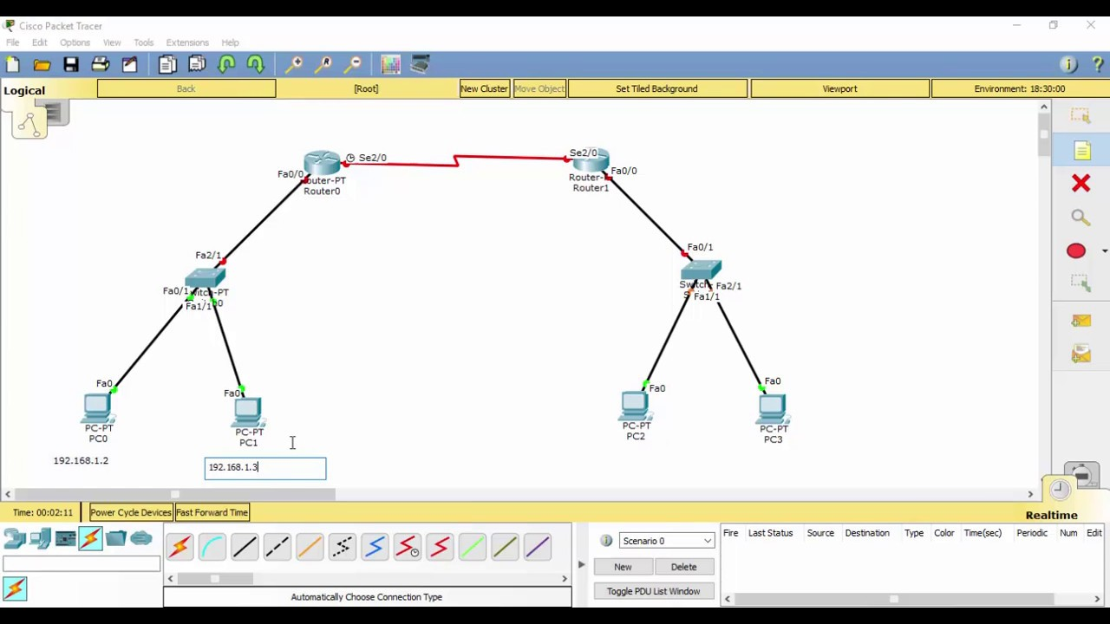

Result:

Thus Configuration of a simple static routing in packet tracer using a simple topology with two routers was done successfully